DEPARTMENT OF COMMERCE & MANAGEMENT
SL.NO | DETAILS OF THE EVENT
1. | Title of The Event | Energy Carnival
2 | Day and Date | 16/04/2026
3 | Venue | Room NO:- 409,407, Auditorium
4 | Organizing Secretary/ Co-Coordinators | Department of Genetics  Dr.Deepa Gopinath  Business Management . Asst.Prof. Ritu U
5 | Chief Guest | Nil
6 | Participants | 98
6 | No of Student and staff present | 83- Students  15- Faculty

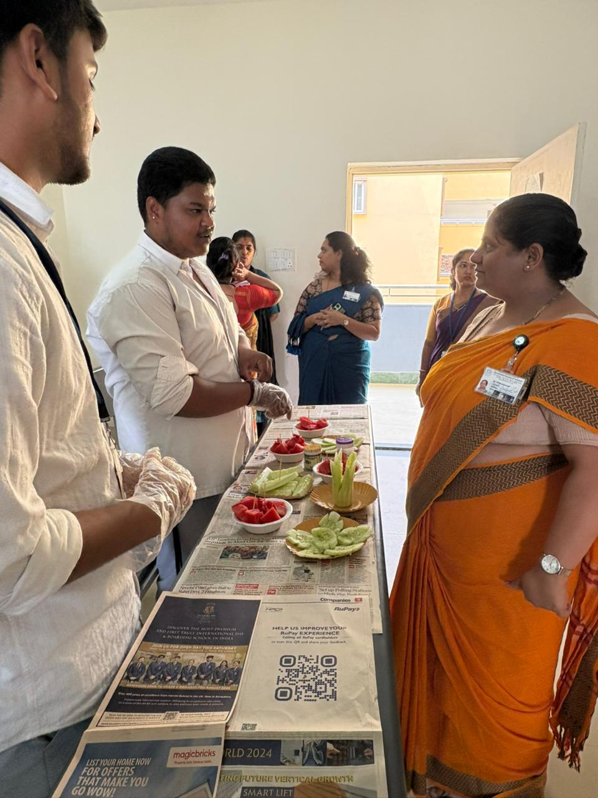 | 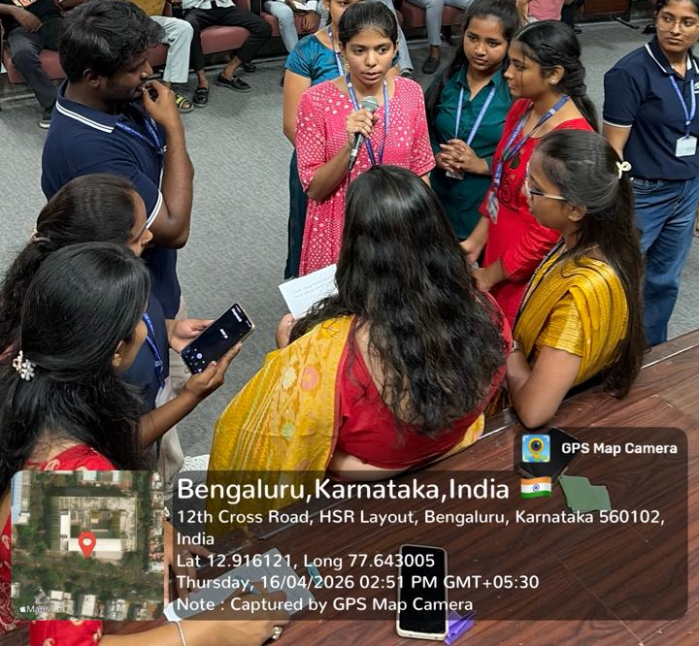

The Eco Club successfully organized "The Energy Carnival," a flagship fest designed to foster environmental stewardship and energy consciousness across the campus. The event was spearheaded by Ms. Ritu U, from the Department of Commerce and Management, under the expert guidance and mentorship of Dr. Deepa Gopinath. The primary objective of this carnival was to engage students in meaningful conservation practices through a series of creative and interactive competitions, highlighting the intersection of sustainable living and modern student life.

Coordinator HOD Vice-Principal Principal

